OS Assigment-4 | SimpleSmartLoader: An Upgraded SimpleLoader in C
Group ID-16
Members: Vaibhav Samrat Waghaye | 2024597, Rigzin Gyalpo | 2024458
Contributions:
Vaibhav-> load and run elf function , segv_handler
Rigzin-> loader cleanup , try load for fault
Implementation:
Our code acts like a smart memory manager that only loads pieces of a program when they are needed, rather than all at once. The key function, loader_map_segment, maps a 4KB page into memory whenever the program tries to access an unmapped page. If the page corresponds to initialized data, it reads the content from the ELF file; if it’s uninitialized (BSS), it creates a zero-filled memory area.
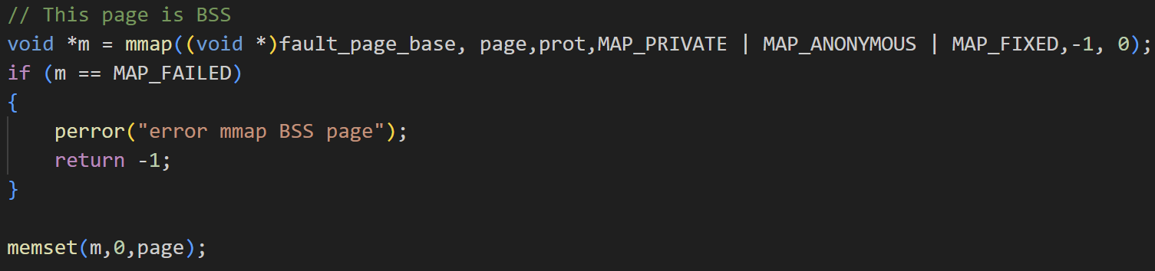
To know which page to load, try_load_for_fault checks all program segments for the one containing the faulting address and calls the mapping function accordingly. The segv_handler listens for page faults (SIGSEGV), counts them, and calls try_load_for_fault to load the needed page. If loading fails, it lets the program crash gracefully.
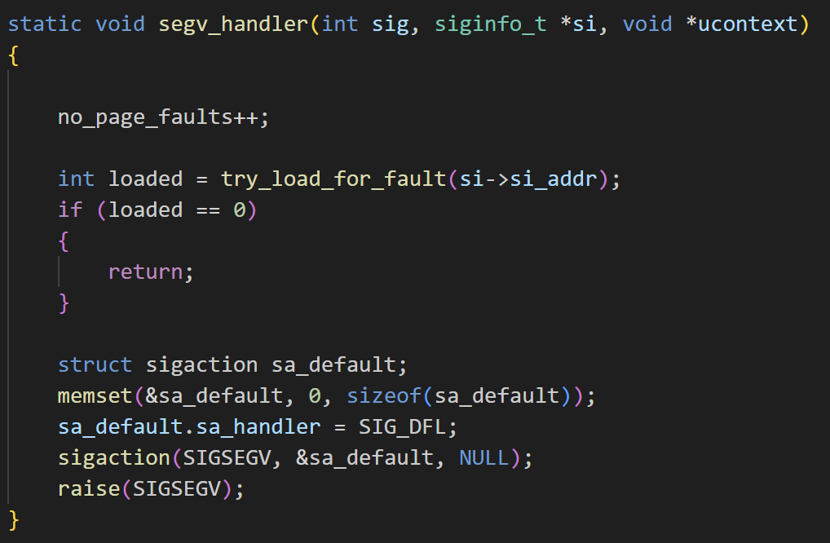
The loader_cleanup function tidies up by unmapping all mapped pages and freeing resources once the program finishes. The load_and_run_elf function sets up the signal handler, reads ELF headers to understand the file layout, opens the executable, and jumps to its entry point to start execution.
After the program runs, it reports statistics like how many page faults and page allocations occurred, and finally calls cleanup.
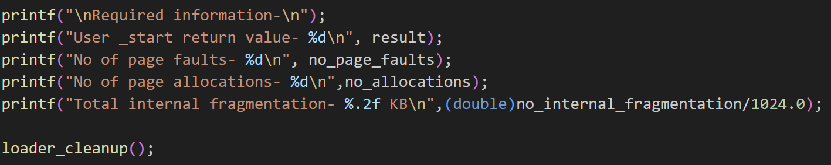
Test Cases:
